DocumentTitle

Distribution
KNS | Others | HT

1 | 11/Jul/2008 | scyang | lmirambel | jgatawa | slawson | Completed
Rev. | Date  (dd/mmm/yyyy) | Author  (Name) | Checked  (Name) | Approved  (Name) | Approved  (Name) | Status
HT |  |  |  |  | Owner

Table of Contents
1. Purpose 3
2. General 3
3. PAF Adjustment 4
3.1 Create Employee 6
3.2 Timesheet Import 6
3.2.1 Automatic Import eTS Timesheet to PAF 6
3.3 Timesheet validations 6
3.4 Transfer of timesheet line items to Hours table 8
3.5 Invoice Cost Calculation 8
3.5.1 Calculation – Labor Costs 8
3.5.2 Calculation – Non Labor Costs 9
3.6 Employee 9
3.7 Process Timesheet 10
3.8 Cost Adjustment 12
3.9 Invoice Edition 14
4. PAF Maintenance 17
5. PAF Reporting 17
5.1 Report Stages 17
5.2 Reporting Sections 18
6. Implementation 19
7. Data storage 19
7.1 Reference tables 20
7.2 Processing tables 20
7.3 History Tables 21
7.4 Roles 21
7.5 PAF Reports 22
7.6 Stored Procedures 22
7.7 Triggers 24
7.8 User Defined Functions 25
8. PAF Database Relational Information 26
8.1 Hours Relational Tables 26

Purpose

The purpose of this document is to provide a comprehensive description of the customized PAF (Personnel Authorization Form) system configuration utilised for the Koniambo project. Where necessary, this document will comment briefly on the relevant external processes that will drive system usage.
This document describes the data entered and maintained within the PAF system, the processes making use of that data, and the means by which the user interacts with the system to perform those processes.
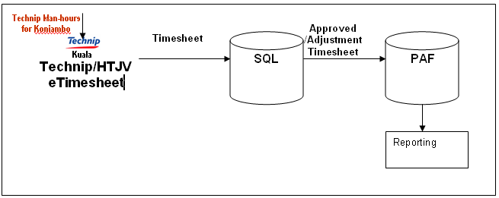
Figure 1 A: General Work Flow

General

The customized PAF system supports the following project functions:
- Project Employee management – personnel recruitment within the project.
- Client invoicing for labour costs – the PAF system in particular provides the ability to invoice in multiple currencies for direct labour costs and reimbursable costs associated with labour, such as office space charges, etc.
- Work hours management, and cost control. This includes the collection of timesheets entered via parent-company systems into a single set of timesheet data, allowing coordinated approval and tracking of hours across the project.
- Reporting in relation to each of the above.

Basically, the customized PAF system consists of two major tools.

- PAF_Adjustments

A window based application to perform major functions below:
  - Personnel recruitment.
  - Process the timesheets received by different companies
  - Set or maintain invoices, including close the monthly invoice
  - Cost adjustments

- PAF Reporting

This section is meant to produce invoice reports to the client.

PAF Adjustment

Customized PAF_ADJUSTMENTS contains four main functions that are
  - Employee: Personnel recruitment in project.
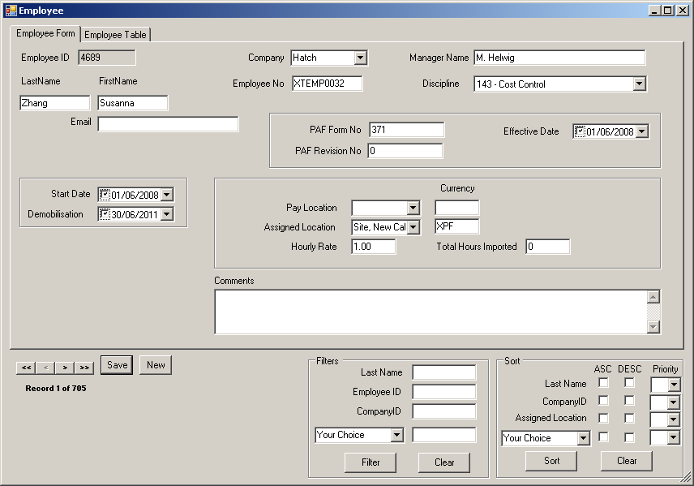

Figure 3 A: Example of Employee Screen

  - Process Timesheets
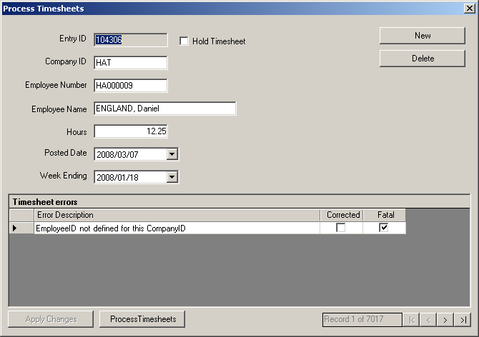

Figure 3 B: Example of Process Timesheet

  - Cost Adjustments

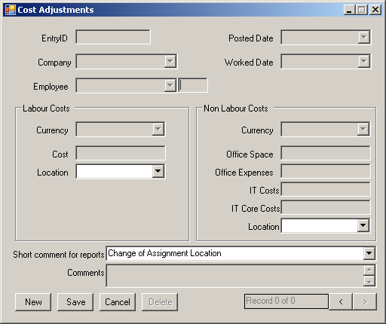

Figure 3 C: Example of Cost Adjustments

  - Invoice Edition: Set or maintain invoice entries, including close the monthly invoice
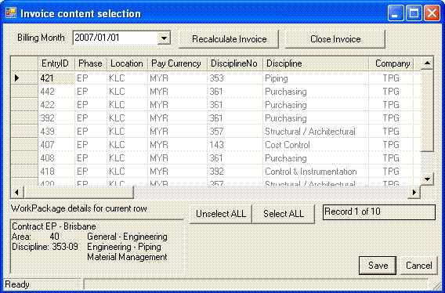
Figure 3 D: Example of Invoice Edition.

Kindly refer to Appendix for the latest User Interfaces.

Create Employee
This section describes PAF system processing in relation to initial creation of a record for new project personnel, and changes later required on that employee’s record.
Employee information entered is automatically saved upon closure of the form, or when moving to a new record using the navigation buttons at the lower left of the form.

Timesheet Import

Based on Figure 1 A, personnel working on the project will continue to enter timesheets via (SQL) eTimesheet systems. Data out of these systems will then be export to the PAF database on a weekly basis. Upon import timesheet data will first be validated by the system against the possible errors as defined in the ErrorDefinition table. The system will then input the data into the Timesheet table, where each timesheet line item, and any associated error/s, can be viewed by the user, and corrective actions performed. At the end of this process the system moves relevant hour’s records into the Hours table.

Automatic Import eTS Timesheet to PAF
The design is that the SQL system will export the approved timesheet which charged to Koniambo cost code into a Temporary table individually. There will be a checking to prevent double posting timesheet. Temporary table’s WeekEndDate is formatted to avoid the year end weekend issue. Later, data will be exported into PAF Timesheet table and once each transaction is succeeded, flag will be updated in Temporary table to indicate the transaction has been exported.
A Job scheduling is created to run the store procedure in weekly basic starting on 3.00 a.m. every Sunday and 3.00 a.m. every Wednesday.

Timesheet validations
After initial import timesheets are validated against each of the possible errors as defined in the ErrorDefinition table. Certain of these errors are defined as fatal errors, meaning that invoicing is not possible for the relevant set of hours and they will not be transferred to the Hours table until errors are resolved. Other errors may be considered warnings, and unless specifically held in the Timesheet table by user request will still be transferred to the Hours table, and thus included in relevant invoices generated.

Error Message | Solution
Invalid company received | - Identify the employee’s CompanyID by using the Employee Form.  - Change the value of CompanyID in Process Timesheets Form to a valid CompanyID.
EmployeeID not defined for this CompanyID | - This entry is not valid since the employeeID does not belongs to the company. There are two possibilities:  - The employee is not exists in the employee database.  - The employee exists in Employee database but under different Company.  - If the employee is not exists in the database, ignore the timesheet.  - If the employee exists in the database, recheck the companyID and change accordingly.
Employee do not have an assigned currency | The employee does not have an assigned currency.  - Check the employee’s assigned currency in Employee Form.
Employee do not have a rate assigned location | The employee does not have a rate assigned location.  - Check the employee’s assigned location in Employee Form.
Information is not available for this employee for the Week Ending Date | The employee’s PAF is not effective for the Week Ending Date.
Employee do not have an hourly rate | Employee do not have an hourly rate  - Check rate in Employee Form.
Information is not available for the assigned location at the week ending date | Location information is not effective at the Week Ending Date.
WeekEndDate do not exists in the calendar | Week End Date is not available.  - Set the Week End Date in the Process Timesheets Form.
Location do not have an Office Others rate defined | Office Others rate is not available at the Week End Date.
Location do not have an Office Space rate defined | Office Space rate is not available at the Week End Date.
Location do not have an Other IT Core rate defined | Other IT Core rate is not available at the Week End Date.
Location do not have an Other IT rate defined | Other IT rate is not available at the Week End Date.
Employee do not have a pay currency | Pay currency is not defined for the employee.  - Check the Employee Form.
Employee do not have a pay location | Pay location is not defined for the employee.  - Check the Employee Form.
Posted date is NULL | Timesheet Posted Date is null.  - Set Posted date in Process Timesheet Form if the information exists.
The time received is after the employee finish date | Week End Date is set after the employee’s demobilisation date.  - Check the Week End Date in Process Timesheets Form.
The time received is from a date before the employee start date | Week End Date was set before the employee’s start date.  - Check the Week End Date in Process Timesheets Form.

Transfer of timesheet line items to Hours table
Hours are transferred from the TimeSheet table to the Hours table. All timesheet line items which do not have fatal errors are transferred. Each record in the Hours table includes not only the details from the TimeSheet table, but also various other details applicable to each set of hours.
At entry into the Hours table, costs associated with the hours are calculated and entered into the Hours table also. For this purpose, the employee’s assignment location, applicable local currency, pay currency and base hourly rate are extracted from the employee’s record. Applicable reimbursable cost rates and multiplier are also extracted from the Location record of the relevant assignment location.
Hours and their associated direct labour costs and reimbursable costs are then available for inclusion in reporting and invoices for the period.
Note that any non-fatal errors (warnings) recorded in TimeSheetErrors are also transferred from this table to HoursErrors table at time of transfer of the set of hours with which the errors are associated. This allows for reporting and continued corrective action against issues with timesheets, both before and after invoicing occurs.
The above process will be repeated for data remaining in the TimeSheet table, as corrective action is taken on errors with timesheets. Further timesheet data imported will simply be added to the TimeSheet table and processed as normal.

Records in the Hours table are only removed if and when data archiving is performed.

Invoice Cost Calculation

Calculation – Labor Costs
The labor cost for a timesheet line item is calculated as following:

[Labor Cost] = [Rate] * [Multiplier] * [Number of hours]

The [Rate] is the [EHAHourlyRate] for the employee.

The [Multiplier] is taken from the Location.

The currency is the [RatePayCurrencyID] for the employee

Calculation – Non Labor Costs
The calculation logic is the same for all non-labor costs: IT Costs, IT Core Costs, Office Space Costs, Others Office Costs.

[IT Costs] = [IT Rate] * [Number of hours]

The [IT Rate] is the rate from the [RateAssignedLocation]

The currency is the [RateAssignedCurrency].

Employee

GENERAL INFORMATION
STORED PROCEDURES & USER DEFINED FUNCTIONS | sp_setapprole  spEmployeeInsert  spEmployeeUpdate
APPLICATION ROLE | PAF_EMPLOYEE_FORM_APPLICATION

LOAD FORM | NEW FORM | SAVE
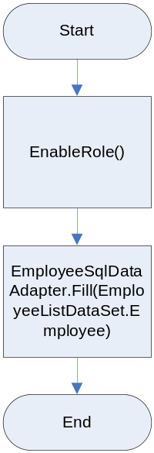 | 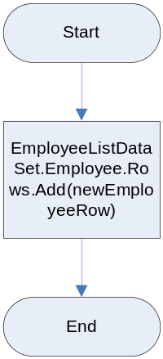 | 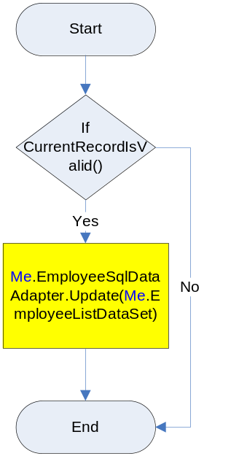

This form is to create and maintain employees working for PAF. Every time user updates employee information, it triggers the EmployeHistoryTrigger to store the previous data into [EmployeeHistory] table. Other triggers that will invoke if update or insert happened are EmployeeUpdateEffectiveDate_Rates and EmployeeTimesheetValidationTrigger.

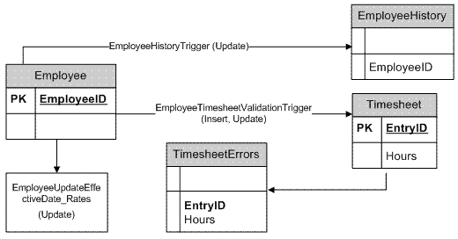
Insert/Update
employee
Figure 3.5 A: Triggers on Employee table.

Process Timesheet

GENERAL INFORMATION
STORED PROCEDURES / USER DEFINED FUNCTIONS | sp_setapprole  ValidateTimesheet  TimesheetUpdate  TimesheetInsert  TimesheetDelete  spValidTimesheetInsertion
APPLICATION ROLE | PAF_PROCESS_TIMESHEET_APPLICATION

PROCESS TIMESHEET | NEW | DELETE
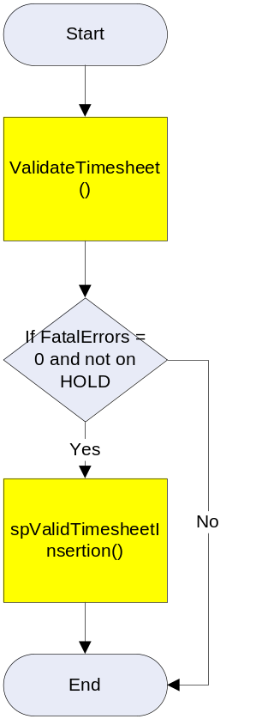 | 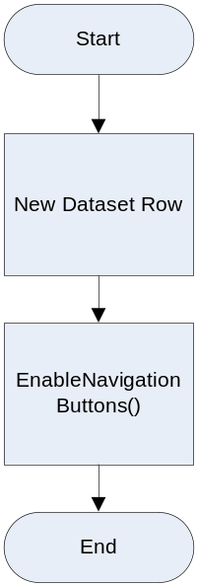 | 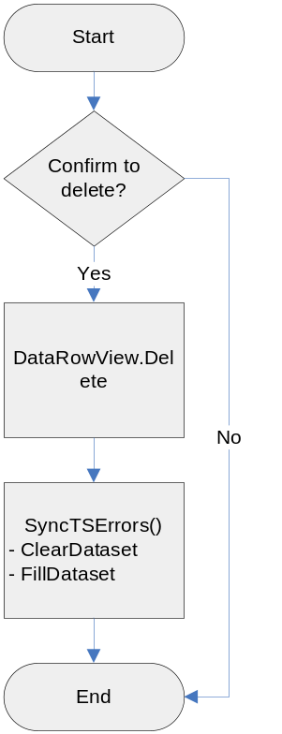

APPLY CHANGES
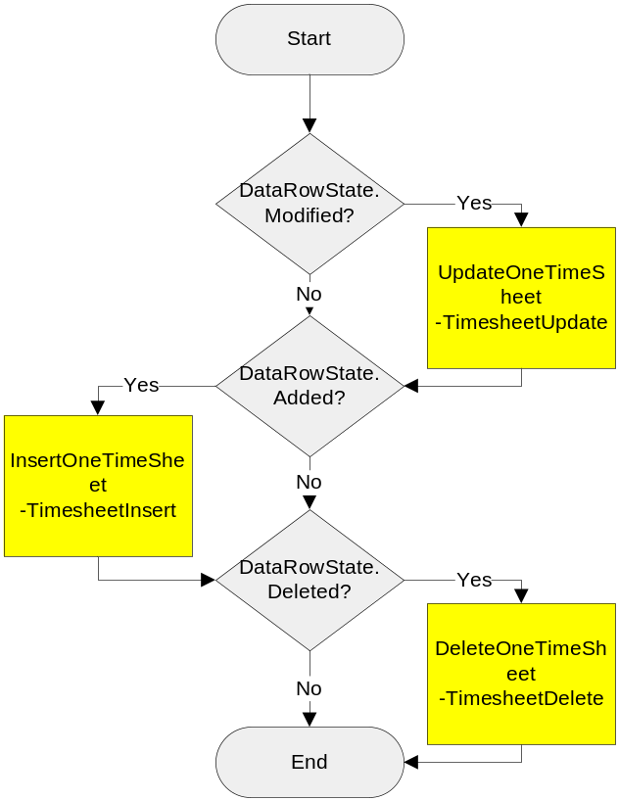

Process Timesheets Form displays all entries from [Timesheet] and [TimesheetErrors] table if any. Users are capable to hold the timesheet entries from being processed by selecting the Hold checkbox. Every changes that you have done in this form must be saved by clicking the ‘Apply Changes’ button. User also can create a new timesheet from this form. If you need to delete any entry, click the Delete button.

PROCESS TIMESHEETS function will transfer the non-fatal error data into [Hours] table (refer to Figure 3.3 A). The rate in [Hours] table will be automatically calculated while the [LabourInvoiceNo] and [NonLabourinvoiceNo] fields are set to NULL.

Successfully moved entries will be deleted from [Timesheet] and [TimesheetErrors] table. The [TotalHoursImported] field in [Employee] table will also be updated with a new value.

Cost Adjustment

GENERAL INFORMATION
STORED PROCEDURES / USER DEFINED FUNCTIONS | sp_setapprole  CostsAdjustmentsInsert  CostsAdjustmentsUpdate  CostsAdjustmentsDelete
APPLICATION ROLE | PAF_COST_ADJUSTMENTS_APPLICATION

Load | New | Save
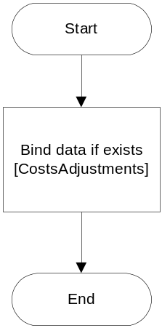 | 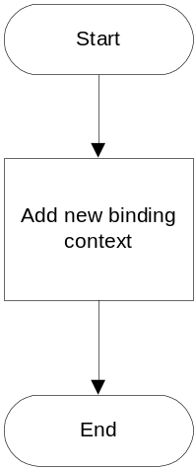 | 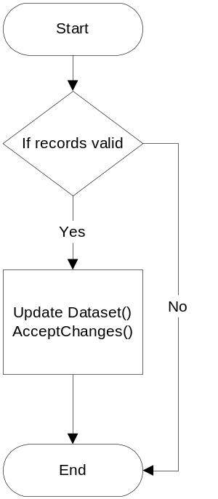

Cancel | Delete
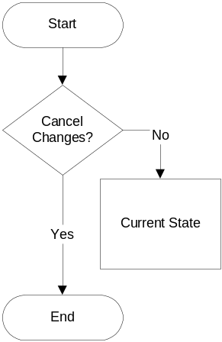 | 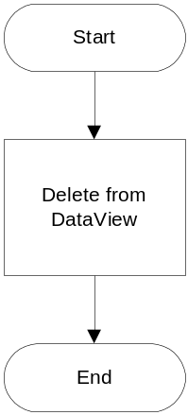

Cost adjustment form is meant for user to include any adjustment entries which can’t be made directly to the [Hours] table.

Adjustments in [Hours] table are indicated by [Adjustment] field value. If the value is ‘A’, it is an adjustment entry. Otherwise the entries are process based on timesheet load.

Invoice Edition

GENERAL INFORMATION
STORED PROCEDURES & USER DEFINED FUNCTIONS | sp_setapprole  GetInvoiceHours  AddHoursToInvoice  RemoveHoursFromInvoice  RecalcHours  CloseInvoice
APPLICATION ROLE | PAF_INVOICE_EDITION_APPLICATION

LOAD | UNSELECT ALL | SELECT ALL
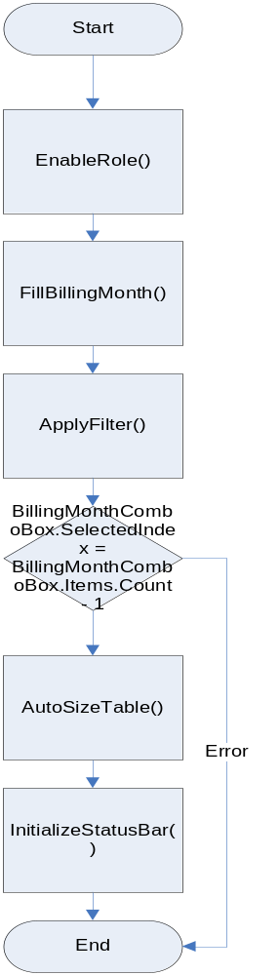 | 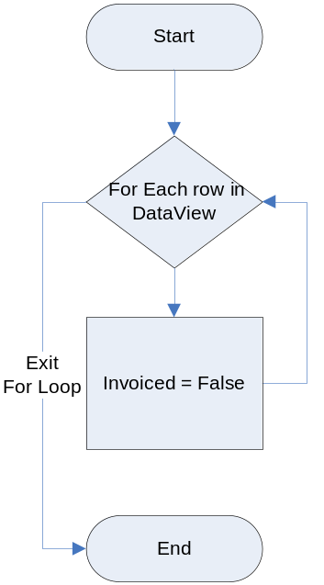 | 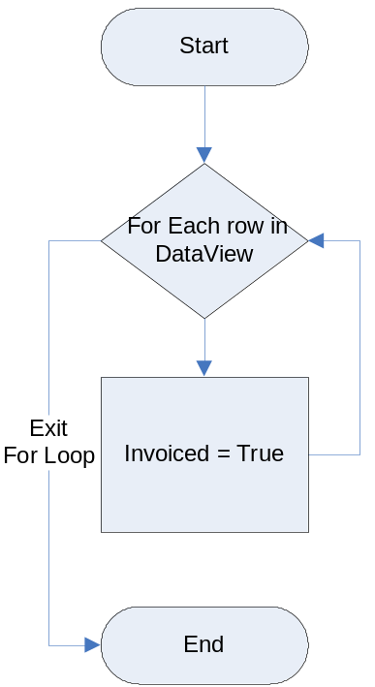

SAVE | RECALCULATE
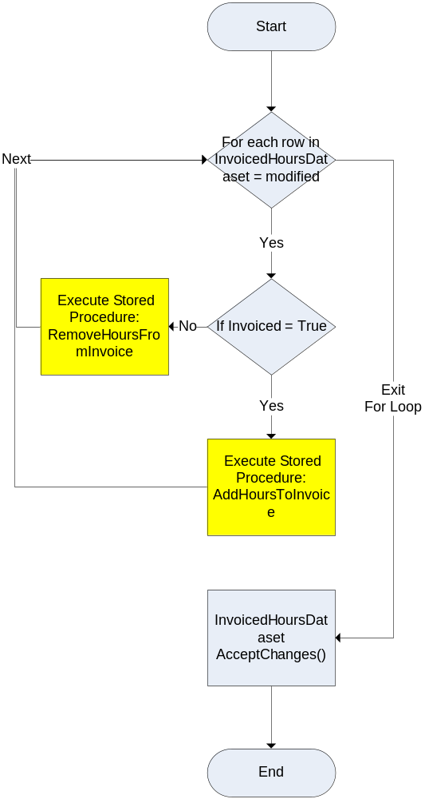 | 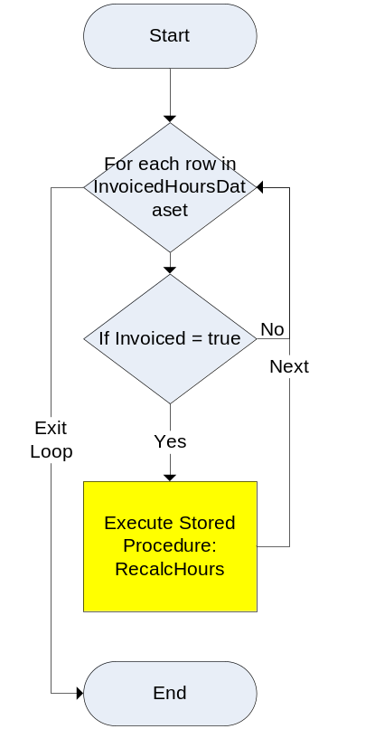

CANCEL | CLOSE INVOICE
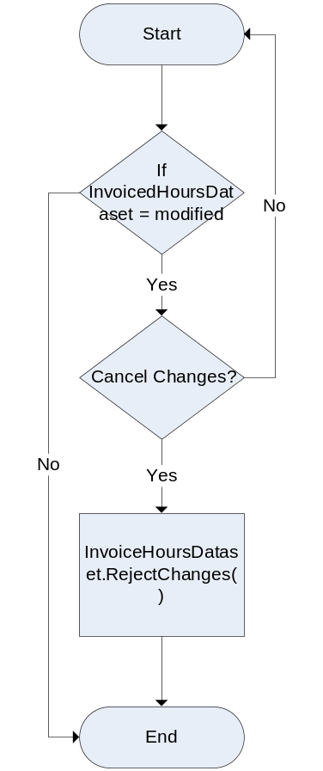 | 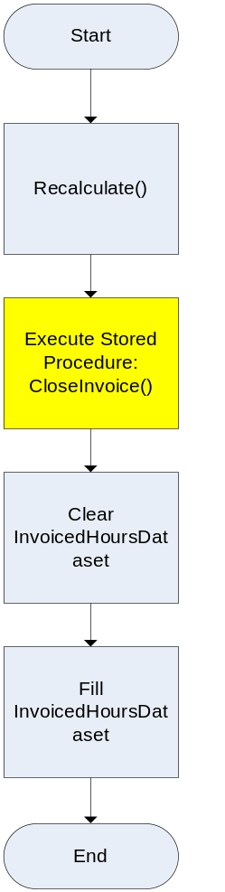

The purpose of Invoice Edition form is to set the value of [LabourInvoiceNo] and [NonLabourInvoiceNo] in [Hours] table. To include the entries into a particular billing month, just select the ‘Included’ checkbox and save the changes. Whenever you clear the ‘Included’ checkbox and apply the changes, both columns will be set to NULL again.

Close Invoice will set the [Closed] value in [Invoices] table to 1. When Invoice is closed, you are not allowed to include or remove the entries from the invoice month. Basically this operation is done after finance people are satisfied with the reports generated from PAF Reports website.

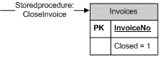
FIGURE 3.6 C: Closed Invoice

PAF Maintenance

PAF maintenance is developed to update the standard code for PAF system, which means this tools will grant access to PAF administrator to insert new reference such as Country into PAF database. The tool is created in Technip Intranet (Tpnet) environment. At this moment, the table should be maintained only by PAF administrator.
The tables are:
    - Calendar: To set the timeframe for PAF and as well as SQL Timesheet.
    - Company: To include company into the PAF invoicing.
    - CostAdjustmentReasons: To set the cost adjustment reasons. The data will be using during cost adjustment via PAF application.
    - Currency: To setup currency for invoicing.
    - Discipline: To set the project’s discipline.
    - Location: To set the location for pay location or the assigned location.
    - Phase: To set the invoice’s phase.

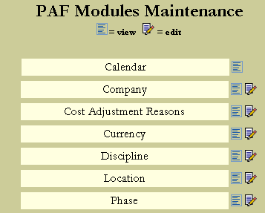

PAF Reporting

Report Stages

Three stages in producing the PAF reports are as below:
- Authoring
- Managing
- Delivery

Authoring
Create reports in report designer.

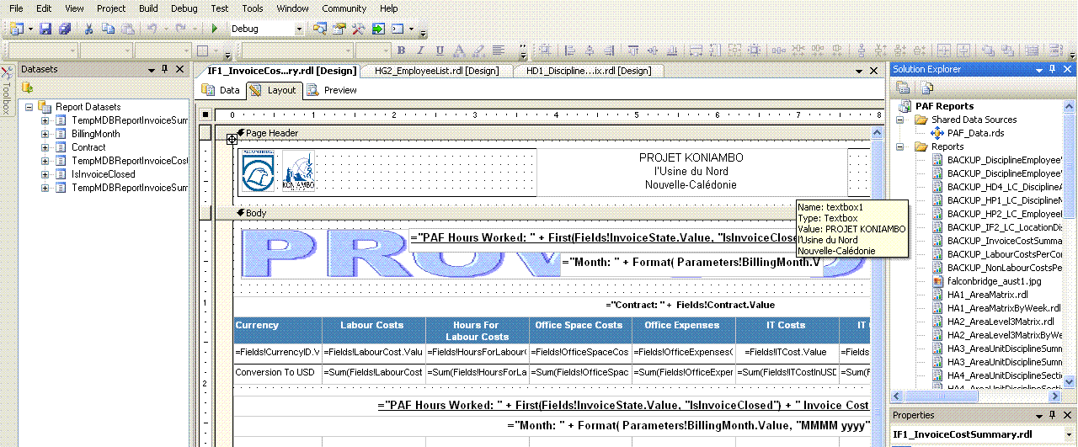

Managing
Manage the created reports in Report Manager (http://<server>/reports)

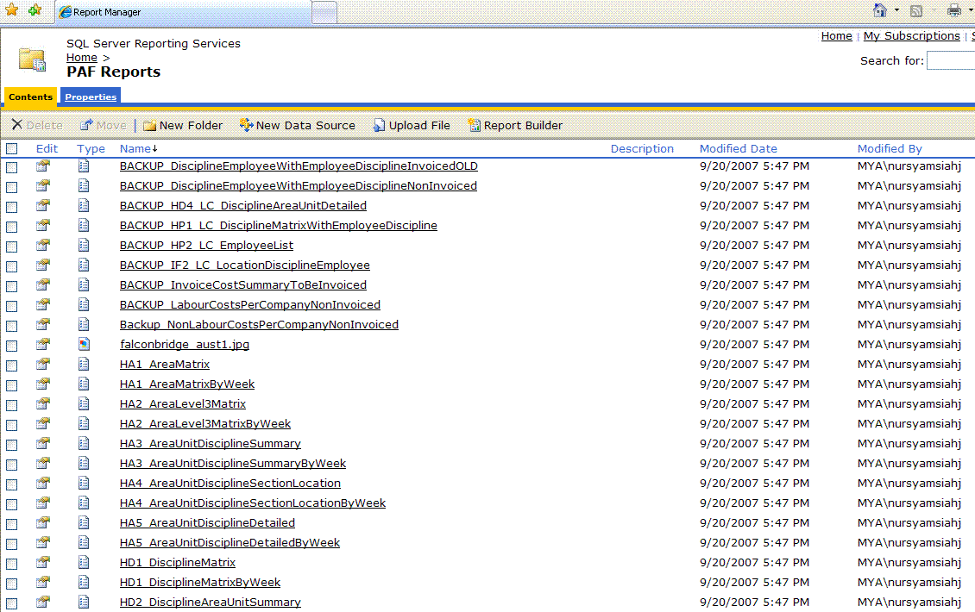

Delivery
Deliver the report using Microsoft Visual Studio .NET and publish it as web.

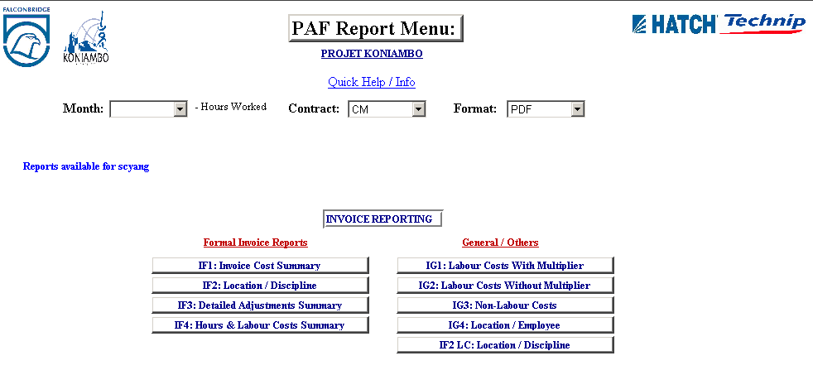

Reporting Sections

The PAF report web:

  - Invoice Reporting
This section is only available for Finance user. These reports display employee costs and hours.

IF1: Invoice Cost Summary
IF2: Location / Discipline
IF3: Detailed Adjustments Summary
IF4: Hours & Labour Costs Summary
IG1: Labour Costs With Multiplier
IG2: Labour Costs Without Multiplier
IG3: Non-Labour Costs
IG4: Location / Employee
IF2 LC: Location / Discipline
SAP Reconciliation NO PAF
SAP Reconciliation Mismatch
SAP HTJV Reconciliation
IF2 Currency Employee
IF1: Invoice Cost Summary/Company
IF2: Employee Rate
IF2: Company Currency Employee
Employee Extraction
Employee Full Extraction
Employee History Extraction
Hours Extraction
Timesheets Extraction
Timesheet Errors Extraction
Prior Week Extraction
SAP-HTJV-PAF Extraction
Monthly Manhour Extraction
Monthly Invoice Extraction
Weekly Extraction

PAF Report main menu is the user interface to provide action button/drop down to query the result from SQL for reporting. There is an option to let the user to select the report month and Contract (EP (Office) or CM (Site)). The report can either be produce in PDF, Excel or Raw Excel format. However, the the conversion is not apply to the Extraction report.

Non-closed Invoice is marked as ‘PROVISIONAL’ when generated, while the closed report is marked as ‘FINAL’.

Implementation

The customised PAF is completely tested by PAF Administrator and the system is well in production since March 2008. Each report created has been evaluated and agreed upon PAF Administrator and Koniambo Finance department.

Data storage

The data maintained within the PAF system includes reference/master data, primary data, and history data. Reference data requires modification only occasionally or rarely. An example of such data includes a table of geographical locations in which personnel working on the project may be based.

Primary data tables are those which will be updated as needed on a daily basis, and includes tables holding information about positions, employees, and worked hours.

Where a change to primary data is made, such as changes to an employee’s details, history tables keep a copy of the previous details. These tables are modified only by the system.

Reference tables

Reference, or master, tables maintained in the system are listed below.
When required, updates to the data held in these tables will be performed only by the system administrator.

Calendar: Maps each week worked on the project with the project reporting and invoicing month to which that week applies.
Company: Maintains a listing of the companies working on the project. Project personnel will come from one of these companies, as will timesheet data.
CostAdjustmentReasons: Defines Cost Adjustment reason.
Currency: A listing of the currencies in which invoices may be generated, depending on the working location of employees, and the currency in which they are paid by their applicable company.
Discipline: Each employee on the project will belong to a single discipline.
ErrorDefinition: Defines exception, or error, situations which may occur with respect to employee timesheets received on the project. Certain types of errors will prevent the relevant hours being invoiced for. Others represent situations that need to be recognised in order to support project functions such as cost control, human resource management, etc. (note that the section titled “Timesheet import” will describe processing in relation to timesheets, including those with errors).
Location: Holds details regarding the various locations in which work on the project may be performed. The table includes the primay operating centres and construction/site locations, as well as other satellite Technip and Hatch locations. Details held here include labour costing details specific to each of the locations, such as labour multipliers.
Phase: Phases of the project for reference purposes.
SAPEmployeeMapping: There will be a possibility that the SAP employee number is updated to another employee number and it will affect the PAF because the employee number has changed and the timesheet might not able to cross reference. In order to resolve the problem, a reference table to keep the old employee number and with the new employee number was created to overcome the issued.

Processing tables

The primary system tables, whose data can be expected to be regularly modified, are listed below. In some cases, changes to this information will occur by user input. For convenient maintenance of such information, the PAF system provides data entry forms for each of the relevant tables.
Other primary tables will be also updated regularly, but updates will be primarily automatic and performed by the system itself. This includes, for example, updates to tables holding hours worked, as imported with timesheets.

Employee: Maintains employee details needed for invoicing. A one-screen form provides convenient interface for maintaining data in this table.

Hours: Following imports of timesheet data, and acceptance/approval of the hours received, all hours worked on the project will be stored in this table. It is from here that costs for invoicing will be extracted.

HoursErrors: Records in this table are each matched to a given set of hours held in the Hours table. The purpose of this is to hold information regarding any errors/exception situations that relate to the relevant set of hours. Data in this table will be automatically updated when applicable in response to system processing (such as following import of timesheet data, or generation of labour costs for invoicing).

Invoices: Maintains summary information regarding client invoices generated by the system.

TimeSheet: Immediately upon timesheet import, timesheet line items are placed in this table. Here they can be viewed, and any errors can be seen and corrective activities commenced, prior to transfer of worked hours to the Hours table (for hours without serious errors). The user can conveniently view the data in this table via the provided form.

TimeSheetErrors: Records in this table hold information on errors that have been recognised in timesheet data imported, and are each matched to a given set of hours held in the TimeSheet table. The user can view these errors in conjunction with viewing the timesheet data imported. However, only the system updates this table, following validations performed on timesheets at the point of import.

PAFManhours: To capture the reconciliation between PAF man-hour and HTJV approved man-hour. The table will store HTJVDB.dbo.PAFExplog’s man-hour, PAF_DATA.dbo.Timesheet’s man-hour, PAF_DATA.dbo.Hours’s man-hour and as well as adjusted man-hours. The purpose is to check the differences between each total man-hour and rectify the problem.

SAPTimesheets: Hold timesheet information via loaded SAP CSV file. Besides, there is a field to determine the SAP employee is existed in PAF.

History Tables
Each of the tables below will hold identical information to those tables from which the data is copied, together with date stamping of the date on which the history was created.

CurrencyHistory: Maintains a history of the currency’s record for tracking of relevant changes make to currency details in Currency table.

DeletedTimeSheet: This table maintains, for history/auditing purposes, a copy of any timesheets deleted from the TimeSheet table by the user.

EmployeeHistory: Maintains a history of an employee’s record for tracking of relevant changes make to employee details in Employee table. Any change to an employee’s record will prompt the system to first copy the employee record to history.

LocationHistory: Maintains a history of the record for a location in the event that any change is made to the details regarding that location. Such a change may include, for example, an adjustment to a given category of reimbursable costs attached to labour.

tblTrackWebReportUsage: Maintains a tracking of the report’s record in this table.

Roles

This application is using Windows Authentication mode to access different functions. To use PAF_ADJUSTMENTS, the domain user must be added into the database. Then set the role according to user’s position. The standard roles defined in this database are shown in Table 2.1 A.

STANDARD ROLE | APPLICATION ROLE
PAF_FINANCE | PAF_COST_ADJUSTMENTS_APPLICATION  PAF_INVOICE_EDITION_APPLICATION  PAF_TIMESHEET_LOAD_APPLICATION  PAF_PROCESS_TIMESHEET_APPLICATION
TABLE 2.1 A: PAF_ADJUSTMENTS ROLES

General user log in is also needed to extract necessary information. The default user created is
USER : pafuser
PASSWORD : p@fuser1

* Application roles contain no members. Users, Microsoft Windows NT® groups, and roles cannot be added to application roles; the permissions of the application role are gained when the application role is activated for the user’s connection through a specific application(s). A user’s association with an application role is due to being capable of running an application that activates the role, rather than being a member of the role.

PAF_FINANCE: Ms. Ludy, Ms. Cheong Weng Kit

PAF Reports

PAF reports is also using Windows Authentication mode to be accessible. The user must be set under WEB_REPORT_VIEW or WEB_REPORT_VIEW_FINANCE.

STANDARD ROLE | Description
WEB_REPORT_VIEW | Grant user to view certain reports only, destined for cost controller.
WEB_REPORT_VIEW_FINANCE | To view all reports, for finance user.
WEB_REPORT_VIEW_FINANCE_RESTRICT | To view all reports, except for Employee Rate.
TABLE 2.2 A: Roles

General user log in is also needed to pull necessary information. The default user created is
USER : pafuser
PASSWORD : p@fuser1

WEB_REPORT_VIEW:
WEB_REPORT_VIEW_FINANCE: Ms. Ludy, Mr. Jaime, Mr. Yang, Ms. Cheong Weng Kit, Mr. Steve Lawson.
WEB_REPORT_VIEW_FINANCE_RESTRICT: Ms. Isabelle

Stored Procedures

Stored procedures | Descriptions
AddErrors | Add/Update errors into [TimeSheetErrors].
AddHoursToInvoice | Insert [Invoice] and update labourInvoiceNo and nonLabourInvoiceNo.
CalendarInsert | HTJV Portal PAF Maintenance usage.
CalendarUpdate | HTJV Portal PAF Maintenance usage.
CheckPAFManhour
CloseInvoice | Update [Invoice] Closed to 1 to close the invoice.
CompanyInsert | HTJV Portal PAF Maintenance usage.
CompanyUpdate | HTJV Portal PAF maintenance usage.
CostAdjustmentReasonsInsert | HTJV Portal PAF maintenance usage.
CostAdjustmentReasonsUpdate | HTJV Portal PAF maintenance usage.
CostsAdjustmentsDelete | Delete Cost Adjustment Entry from [Hours].
CostsAdjustmentsInsert | Insert Cost Adjustment Entry from [Hours].
CostsAdjustmentsUpdate | Update Cost Adjustment Entry in [Hours]
CurrencyInsert | HTJV Portal PAF maintenance usage.
CurrencyUpdate | HTJV Portal PAF maintenance usage.
DisciplineInsert | HTJV Portal PAF maintenance usage.
DisciplineUpdate | HTJV Portal PAF maintenance usage.
EmployeeExtraction | Extract custom employee data for report.
EmployeeFullExtraction | Extract full employee data for report.
EmployeeHistoryExtraction | Extract Employee History data for report.
GeneratePAFManhour | Schedule task to retrieve the HTJV.pafexplog man-hour and a few table in PAF_Data and safe the data into PAfManhours table.
HoursExtraction | Extract Hours data for report.
GetTimesheetErrors | Get timesheet errors. This is in used when generate the TimesheetErrors Extraction report.
IF1_InvoiceSummary | Reports
IF1_InvoiceSummaryAdjustments | Reports
IF1_InvoiceSummaryAdjustments_company | Reports
IF1_InvoiceSummaryWithoutAdjustments | Reports
IF1_InvoiceSummaryWithoutAdjustments_company | Reports
IF2_EmployeeList | Reports
IF3_CompleteAdjustmentSummary | Reports
IF4_ProjectHoursLabourCostsSummary | Reports
IG1_LabourCostPerCompany | Reports
IG3_NonLabourCostPerCompany | Reports
IG4_GetInvoicedEmployeeListPerLocation | Reports
LocationInsert | HTJV Portal PAF maintenance usage.
LocationUpdate | HTJV Portal PAF maintenance usage.
MonthlyExtraction | Generate monthly actual man-hour report.
MonthlyInvoiceExtraction | Generate monthly invoiced man-hour report.
PhaseInsert | HTJV Portal PAF maintenance usage.
Phaseupdate | HTJV Portal PAF maintenance usage.
PhaseWeekExtraction | Reports
ProcessTimesheets | When everything is checked run spValidTimesheetInsertion.
RecalcHours | To recalculate Hours and update the [Hours].
RemoveHoursFromInvoice | Removing Hours from [Invoice].
SAPHTJVPAFComparizon | Reports
spEmployeeInsert | Insert new record in employee table
spEmployeeUpdate | Update employee record in employee table
spIsInvoiceClosed | Use by the reports
splitlines
spTimesheetInsert | Insert new record in timesheet table
spValidTimesheetInsertion | Insert data from [Timesheet] into [Hours].
TimeSheetDelete | Delete data from timesheet
TimesheetInsert | Insert data into timesheet
TimesheetsExtraction | Extract Timesheets for report.
TimesheetUpdate | Update data in timesheet table
ValidateTimeSheet | Validated the timesheet
WeeklyExtraction | Generate weekly report.

Triggers
Table | Triggers |  | Description
Calendar | Name | CalendarTimesheetValidation | Execute ValidateTimesheet stored procedure
Calendar | Events | Insert  Update | Execute ValidateTimesheet stored procedure
Calendar | Affected Stored Procedures | ValidateTimesheet | Execute ValidateTimesheet stored procedure
Currency | Name | CurrencyHistoryTrigger | Insert previous data into [CurrencyHistory] table.
Currency | Events | Update | Insert previous data into [CurrencyHistory] table.
Currency | Affected Stored Procedures | - | Insert previous data into [CurrencyHistory] table.
Employee | Name | EmployeeHistoryTrigger | Insert previous employee data into EmployeeHistory table where both previous and new data are not the same.
Employee | Events | Update
Employee | Affected Stored Procedures | -
Employee | Name | EmployeeTimesheetValidationTrigger | Validate any new insert or update employee with timesheet table.
Employee | Events | Insert  Update
Employee | Affected Stored Procedures | ValidateTimesheet
Employee | Name | EmployeeUpdateEffectiveDate_Rates | If new and previous RatePayLocation are different but the EHAhourlyRate or R&RHourlyRate are the same as previous data, rollback transaction.
Employee | Events | Update
Employee | Affected Stored Procedures | -
Hours | Name | AdjustmentTrigger | Set  Hours, RatePayLocation, RateAssignlocation, Multiplier, RateSalBaseHourlyRate, OtherOfficeSpaceRate, OtherOfficeExpensesRate,  OtherITRate, OtherITCoreRate to 0  if the entry is an adjustment.
Hours | Events | Insert
Hours | Affected Stored Procedures | -
Location | Name | LocationHistoryTrigger | Insert previous data into LocationHistory table.
Location | Events | Update | Insert previous data into LocationHistory table.
Location | Affected Stored Procedures | - | Insert previous data into LocationHistory table.
Location | Name | LocationTimesheetValidationTrigger | Execute ValidateTimesheet stored procedure.
Location | Events | Insert  Update | Execute ValidateTimesheet stored procedure.
Location | Affected Stored Procedures | ValidateTimesheet | Execute ValidateTimesheet stored procedure.
Timesheet | Name | TimesheetValidationTrigger | ValidateTimesheet entries by executing ValidateTimesheet stored procedure.
Timesheet | Events | Insert  Update
Timesheet | Affected Stored Procedures | ValidateTimesheet

User Defined Functions

List of functions

Functions
GetEmployeeRecord | Use in most stored procedures
GenerateHTJVManhours | Return HTJV approved and unapproved man-hour.
GetHoursMatrix1
GetLocationRecord | Use in most stored procedures. To get the location based on week ending date and effective date.
GetInvoiceHours | Use in Invoice Edition.
GetWeeksOfTheMonth | Will be using to identify the week of the month.
IF2_CompanyCurrencyEmployee | Use in reports
IF2_CurrencyEmployee | Use in reports
IF2_LC_LocationDisciplineEmployee | Use in reports
IF2_RateEmployee | Use in reports
RetrieveInvoiceHoursByInvoiceNo | Use in IF2_GetEmployeeListWithEmployee  DisciplineInvoiced
IG4_RetrievalRequestByMonth | Use in IG4_GetInvoicedEmployeeListPerLocation stored procedure
IG4_RetrieveInvoiceHoursByMonth | Use in IG4 reports.

List of scalar-valued functions

Scalar-valued
ContainNonInvoicedHours | To check [Calendar].projectWeekEndingDate with [Hours].projectWeekEndingDate contains Non-Invoiced Hours.
GetConversionrate | Return rate from [Invoice] or [Currency].
InitCap | Set the first Character as capital, the rest will be small letter.

PAF Database Relational Information

Hours Relational Tables

Table: Calendar
Column Name | Type | Description
ProjectWeekEndingDate | datetime | The week-end date of a given project week.
ProjectBillingMonth | datetime | The project billing month to which the week is assigned.
WeekOfYear | int | Incremental week number for the current year.
ProjectBillingYear | int | The project billing year to which the week is assigned.

Table: Company
Column Name | Type | Description
CompanyID | char | Three-letter company abbreviation.
CompanyName | varchar | Company full name.

Table: Currency
Column Name | Type | Description
CurrencyID | char | Three-letter country currency abbreviation
Description | char | Country currency description.
CurrencyTo ProjectRate | float | Ratio to USD
Comments | varchar | Remarks

Table: Discipline
Column Name | Type | Description
DisciplineID | int | Unique Discipline identifier.
DisciplineNo | char
Description | varchar | Unique Discipline description.
SortOrder | int | DisciplineID column sort hierarchy.

Table: Employee
Column Name | Type | Description
EmployeeID | int | Unique employee identifier
CompanyID | char | Three-letter company abbreviation.
CompanyEmployeeNo | char | Specific company employee identification number.
DisciplineID | int | Discipline identifier
LastName | varchar | Employee last name
FirstName | varchar | Employee first name
TotalHoursImported | float | Employee total worked hours (invoiced & non-invoiced).
CompanyLineManagerName | varchar | Company Unit manager
Email | Varchar | Email Address
Comments | varchar | Remarks
PAFNo | varchar | A file number referring to the documentation via which information about the employee’s assignment was submitted.
PAFRevisionNO | int | Revision number of the employee’s latest record.
StartDate | datetime | Employee project start date.
RatePayLocation | char | The individual’s pay (or home, or reporting) location.
RatePayCurrencyID | char | The currency in which the individual is paid.
EHAHourlyRate | decimal | The individual’s base hourly rate.
RateAssignLocation | char | Employee location for non-labour costs.
RateAssignCurrencyID | char | Employee non-labour currency
ActualDemobilisationDate | datetime | Actual employee finish date on project date.
Creator | varchar | Person who created the Employee record.
CreationDate | datetime | Date of creation.
EffectiveDate | datetime | Date of the effectiveness of the PAF form.

Table: Hours
Column Name | Type | Description
EntryID | int | Unique identifier inserted from Timesheet table
CompanyID | char | Three-letter company abbreviation
EmployeeID | int | Unique employee identifier
PostedDate | datetime | Latest ProjectWeekEndingDate from when timesheet loaded.
ProjectWeekEndingDate | datetime | Represents the week ending date of the week in which the hours were worked.
ParentCompanyPostedDate | datetime | Date from parent company when employee timesheet was processed.
Hours | decimal | Employee working hours from current timesheet.
RatePayLocation | char | Employee’s pay location.
RatePayCurrencyID | char | Employee’s pay currency.
RateSalBaseHourlyRate | decimal | Employee hourly base salary rate
RateAssignLocation | char | Employee location for non-labour costs.
RateAssignCurrencyID | char | Employee non-labour currency
Multiplier | float | Employee pay-rate adjuster
OtherOfficeSpaceRate | decimal | Employee non-labour area charge rate
OtherOfficeExpensesRate | decimal | Employee non-labour area charge rate
OtherITRate | decimal | Employee non-labour area charge rate
OtherITCoreRate | decimal | Employee non-labour area charge rate
OtherOfficeSpace | decimal | Employee non-labour area hours charged
OtherOfficeExpenses | decimal | Employee non-labour area hours charged
OtherIT | decimal | Employee non-labour area hours charged
OtherITCore | decimal | Employee non-labour area hours charged
LabourCost | decimal | Employee labour hours charged
LabourInvoiceNo | char | Refers to the invoice number in which the direct labour cost for this set of hours is included.
NonLabourInvoiceNo | char | Refers to the invoice number in which the non-labour reimbursable costs for this set of hours have been included.
Adjustment | char | Invoice cost adjustment
AdjustmentShortComment | varchar | Brief adjustment comment
AdjustmentLongComment | varchar | Detailed adjustment comment
AdjustmentDate | datetime | Adjustments date
AdjustmentUser | varchar | Adjustment by.
Loadedby | Varchar | Person who loaded the data.
LoadMode | char

Table: HoursErrors
Column Name | Type | Description
EntryID | int | Unique identifier inserted from TimesheetErrors table
ErrorID | char | Description of error
ErrorDate | datetime | Date error occurred
Validated | bit | Has error been fixed?
ValidatedDate | datetime | Date error fixed.

Table: Invoices
Column Name | Type | Description
InvoiceNo | char | Unique invoice identifier
InvoicingDate | datetime | Date invoice created
ProjectBillingMonth | datetime | Invoice period (month).
CurrencyID | char | Three-letter country currency abbreviation
CurrencyToUSD | float | Country currency conversion to USD.
ProducedBy | varchar | Invoice generated by.
ProducedDate | datetime | Invoiced generated date.
Closed | Bit | Flag to indicate the invoice is closed.
ClosedBy | Varchar | Person who closed the invoice.
CloseDate | Datetime | Date of closing the invoice.

Table: Location
Column Name | Type | Description
LocationID | char | Three-letter country abbreviation.
LocationName | varchar | Country full length name.
CompanyID | char | Three-letter company abbreviation.
CurrencyID | char | Three-letter country currency abbreviation
StandardWorkingHours | int | Employee standard week working hours.
Multiplier | float | Applicable overhead multiplier for this location, according to contract conditions.
OtherOfficeSpace | decimal | Hourly rate for office space charge applicable for the location.
OtherOfficeExpenses | decimal | Hourly rate for general office expenses applicable for the location.
OtherIT | decimal | Hourly rate for general IT costs applicable for this location.
OtherITCore | decimal | Hourly rate for core IT support costs applicable for this location.
OtherTotal | decimal | Hourly combined rate for reimbursable costs attached to hours worked
Revision | int | Revision number of this record for the location. Initially set to zero, and increments by one each time the location details change.
RevisionEffectiveDate | datetime | Effective date of the current revision to the location record
Comments | varchar | Remarks
SortOrder | int | Column sort hierarchy.
PhaseID | Int | Reference key to Phase Table.

Table: Phase
Column Name | Type | Description
PhaseID | int | Unique Phase identifier.
Description | char | Phase description.

Table: TimeSheets
Column Name | Type | Description
EntryID | int | Unique entry identifier.
CompanyID | char | Three-letter company abbreviation.
CompanyEmployeeNo | char | Specific company employee identification number.
EmployeeName | varchar | Employee name.
Hours | float | Employee working hours from current timesheet.
PostedDate | datetime | Timesheet processed date.
WeekEndDate | datetime | The week ending date of the week in which this set of hours was worked.
Hold | bit | Restrict employee Timesheet data from being processed.
AdjustingEntryID | int | Flags adjustment entries.
Loadedby | Varchar | Person who loaded the data.
LoadMode | char | Loading Mode: Such as Manual

Table: TimeSheetErrors

Column Name | Type | Description
EntryID | int | Unique entry identifier from TimeSheets.
ErrorID | char | Description of error
ErrorDate | datetime | Date error occurred
Validated | bit | Flag to indicate the error has been fixed.
ValidatedDate | datetime | Date error fixed.

HOURS RELATIONAL DIAGRAM
Employee

EmployeeID (PK)
CompanyID (FK)
CompanyEmployeeNo
DisciplineID (FK)
LastName
FirstName
TotalHoursImported
CompanyLineManagerName
Email
Comments
PAFNo
PAFRevisionNO
StartDate
RatePayLocation
RatePayCurrencyID
EHAHourlyRate
RateAssignLocation
RateAssignCurrencyID
ActualDemobilisationDate
Creator
CreationDate
EffectiveDate

Calendar

ProjectWeekEndingDate (PK)
ProjectBillingMonth
WeekOfYear
ProjectBillingYear
Phase

PhaseID (PK)
Description

Company

CompanyID (PK)
CompanyName
Location

LocationID (PK)
LocationName
CompanyID (FK)
CurrencyID (FK)
StandardWorkingHours
Multiplier
OtherOfficeSpace
OtherOfficeExpenses
OtherIT
OtherITCore
OtherTotal
Revision
RevisionEffectiveDate
Comments
SortOrder
PhaseID (FK)
Currency

CurrencyID (PK)
Description
CurrencyTo ProjectRate
Comments
Invoices

InvoiceNO (PK)
InvoicingDate
ProjectBillingMonth
CurrencyID (FK)
CurrencyToUSD
ProducedBy
ProducedDate
Closed
ClosedBy
CloseDate
Hours

EntryID (PK)
CompanyID (FK)
EmployeeID (FK)
PostedDate
ProjectWeekEndingDate (FK)
ParentCompanyPostedDate
Hours
RatePayLocation (FK)
RatePayCurrencyID (FK)
RateSalBaseHourlyRate
RateAssignLocation (FK)
RateAssignCurrencyID (FK)
Multiplier
OtherOfficeSpaceRate
OtherOfficeExpensesRate
OtherITRate
OtherITCoreRate
OtherOfficeSpace
OtherOfficeExpenses
OtherIT
OtherITCore
LabourCost
LabourInvoiceNo (FK)
NonLabourInvoiceNo (FK)
Adjustment
AdjustmentShortComment
AdjustmentLongComment
AdjustmentDate
AdjustmentUser
Loadedby
LoadedMode
HoursErrors

EntryID (PK)
ErrorID
ErrorDate
Validated
ValidatedDate
Timesheets

EntryID (PK)
CompanyID
CompanyEmployeeNo
EmployeeName
Hours
PostedDate
WeekEndDate
Hold
AdjustingEntryID
Loadedby
LoadMode
TimeSheetErrors

EntryID (PK) (FK)
ErrorID (FK)
ErrorDate
Validated
ValidatedDate
Export

Appendix A
Customized PAF General Design Flow and User Interfaced

E-Timesheet
PAF_Data
Transfer
Hours
Error?
TimesheetErrors
Company, Employee Number, Employee Name, Hours (OT + Normal manhours), Posted date, week ending (Start date is on Saturday and end date is on Friday)
Code Adjustment is done in E-Timesheet.
Reports
Cost Adjustment
Invoice Edition
Invoicing
Yes
No

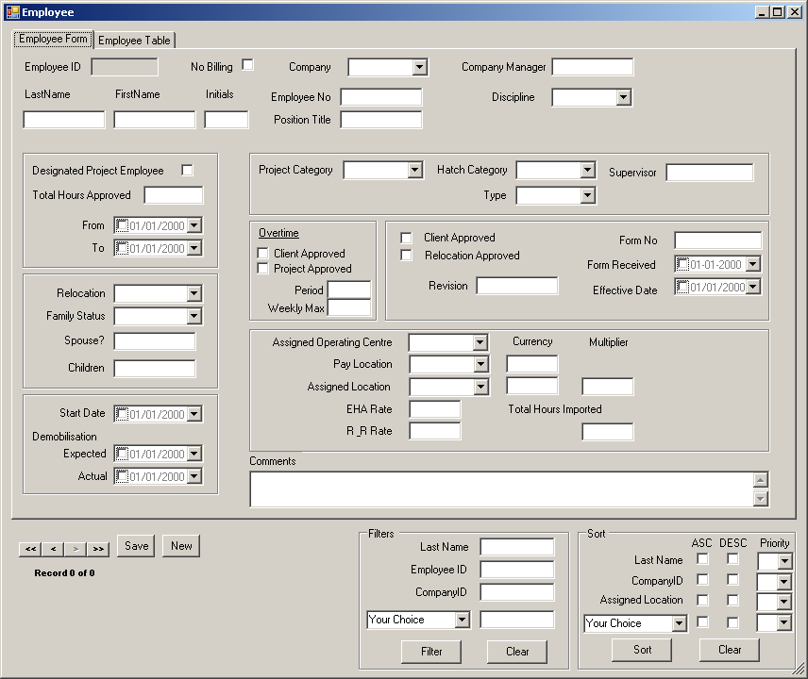
Rename Manager Name
Put Discipline Code with Description
e.g. 110 Account.
Adding Email Address.

Appendix B
Detailed Definition of Table Fields

Table: Calendar
Column Name | Type | Description
ProjectWeekEndingDate | datetime | The week-end date of a given project week.
ProjectBillingMonth | datetime | The project billing month to which the week is assigned.
WeekOfYear | int | Incremental week number for the current year.
ProjectBillingYear | int | The project billing year to which the week is assigned.

Table: Company
Column Name | Type | Description
CompanyID | char | Three-letter company abbreviation.
CompanyName | varchar | Company full name.

Table: CostAdjustmentReasons
Column Name | Type | Description
ShortComment | varchar | Reference comment on Cost Adjustments.

Table: Currency
Column Name | Type | Description
CurrencyID | char | Three-letter country currency abbreviation
Description | char | Country currency description.
CurrencyTo ProjectRate | float | Ratio to USD
Comments | varchar | Remarks

Table: CurrencyHistory
Column Name | Type | Description
CurrencyID | char | Three-letter country currency abbreviation
Description | char | Country currency description.
CurrencyTo ProjectRate | float | Ratio to USD
Comments | varchar | Remarks
HistoryDate | Datetime | Date of creation
HistoryUser | Datetime | Creator

Table: DeletedTimesheet
Column Name | Type | Description
EntryID | int | Unique entry identifier.
CompanyID | char | Three-letter company abbreviation.
CompanyEmployeeNo | char | Specific company employee identification number.
EmployeeName | varchar | Employee name.
Hours | float | Employee working hours from current timesheet.
PostedDate | datetime | Timesheet processed date.
WeekEndDate | datetime | The week ending date of the week in which this set of hours was worked.
Hold | bit | Restrict employee Timesheet data from being processed.
AdjustingEntryID | int | Flags adjustment entries.
Loadedby | varchar | Person who loaded the data
LoadMode | Char | Loaded Mode
DeletedDate | Datetime | Deleting timesheet date
DeletedBy | Varchar | Person who deleted the data

Table: Discipline
Column Name | Type | Description
DisciplineID | int | Unique Discipline identifier.
DisciplineNo | char | Discipline Number set by Project.
Description | varchar | Unique Discipline description.
SortOrder | int | DisciplineID column sort hierarchy.

Table: Employee
Column Name | Type | Description
EmployeeID | int | Unique employee identifier
CompanyID | char | Three-letter company abbreviation.
CompanyEmployeeNo | char | Specific company employee identification number.
DisciplineID | int | Discipline identifier
LastName | varchar | Employee last name
FirstName | varchar | Employee first name
TotalHoursImported | float | Employee total worked hours (invoiced & non-invoiced).
CompanyLineManagerName | varchar | Company Unit manager
Email | Varchar | Email Address
Comments | varchar | Remarks
PAFNo | varchar | A file number referring to the documentation via which information about the employee’s assignment was submitted.
PAFRevisionNO | int | Revision number of the employee’s latest record.
StartDate | datetime | Employee project start date.
RatePayLocation | char | The individual’s pay (or home, or reporting) location.
RatePayCurrencyID | char | The currency in which the individual is paid.
EHAHourlyRate | decimal | The individual’s base hourly rate.
RateAssignLocation | char | Employee location for non-labour costs.
RateAssignCurrencyID | char | Employee non-labour currency
ActualDemobilisationDate | datetime | Actual employee finish date on project date.
Creator | varchar | Person who created the Employee record.
CreationDate | datetime | Date of creation.
EffectiveDate | datetime | PAF form effectiveness date.

Table: EmployeeHistory
Column Name | Type | Description
EmployeeID | int | Unique employee identifier
CompanyID | char | Three-letter company abbreviation.
CompanyEmployeeNo | char | Specific company employee identification number.
DisciplineID | int | Discipline identifier
LastName | varchar | Employee last name
FirstName | varchar | Employee first name
TotalHoursImported | float | Employee total worked hours (invoiced & non-invoiced).
CompanyLineManagerName | varchar | Company Unit manager
Email | Varchar | Email Address
Comments | varchar | Remarks
PAFNo | varchar | A file number referring to the documentation via which information about the employee’s assignment was submitted.
PAFRevisionNO | int | Revision number of the employee’s latest record.
StartDate | datetime | Employee project start date.
RatePayLocation | char | The individual’s pay (or home, or reporting) location.
RatePayCurrencyID | char | The currency in which the individual is paid.
EHAHourlyRate | decimal | The individual’s base hourly rate.
RateAssignLocation | char | Employee location for non-labour costs.
RateAssignCurrencyID | char | Employee non-labour currency
ActualDemobilisationDate | datetime | Actual employee finish date on project date.
Creator | varchar | Person who created the Employee record.
CreationDate | datetime | Date of creation.
EffectiveDate | datetime | PAF form effectiveness date.
HistoryDate | Datetime | History created date
HistoryUser | varchar | History creator

Table: ErrorDefinition
Column Name | Type | Description
ErrorID | char | Unique identifier.
ErrorMessage | varchar | Message description
Fatal | bit | Error code.

Table: Hours
Column Name | Type | Description
EntryID | int | Unique identifier inserted from Timesheet table
CompanyID | char | Three-letter company abbreviation
EmployeeID | int | Unique employee identifier
PostedDate | datetime | Latest ProjectWeekEndingDate from when timesheet loaded.
ProjectWeekEndingDate | datetime | Represents the week ending date of the week in which the hours were worked.
ParentCompanyPostedDate | datetime | Date from parent company when employee timesheet was processed.
Hours | decimal | Employee working hours from current timesheet.
RatePayLocation | char | Employee’s pay location.
RatePayCurrencyID | char | Employee’s pay currency.
RateSalBaseHourlyRate | decimal | Employee hourly base salary rate
RateAssignLocation | char | Employee location for non-labour costs.
RateAssignCurrencyID | char | Employee non-labour currency
Multiplier | float | Employee pay-rate adjuster
OtherOfficeSpaceRate | decimal | Employee non-labour area charge rate
OtherOfficeExpensesRate | decimal | Employee non-labour area charge rate
OtherITRate | decimal | Employee non-labour area charge rate
OtherITCoreRate | decimal | Employee non-labour area charge rate
OtherOfficeSpace | decimal | Employee non-labour area hours charged
OtherOfficeExpenses | decimal | Employee non-labour area hours charged
OtherIT | decimal | Employee non-labour area hours charged
OtherITCore | decimal | Employee non-labour area hours charged
LabourCost | decimal | Employee labour hours charged
LabourInvoiceNo | char | Refers to the invoice number in which the direct labour cost for this set of hours is included.
NonLabourInvoiceNo | char | Refers to the invoice number in which the non-labour reimbursable costs for this set of hours have been included.
Adjustment | char | Invoice cost adjustment
AdjustmentShortComment | varchar | Brief adjustment comment
AdjustmentLongComment | varchar | Detailed adjustment comment
AdjustmentDate | datetime | Adjustments date
AdjustmentUser | varchar | Adjustment by.
Loadedby | Varchar | Person who loaded the data.
LoadMode | char | Indicate load mode, such as Manual.

Table: HoursErrors
Column Name | Type | Description
EntryID | int | Unique identifier inserted from TimesheetErrors table
ErrorID | char | Description of error
ErrorDate | datetime | Date error occurred
Validated | bit | Has error been fixed?
ValidatedDate | datetime | Date error fixed.

Table: Invoices
Column Name | Type | Description
InvoiceNo | char | Unique invoice identifier
InvoicingDate | datetime | Date invoice created
ProjectBillingMonth | datetime | Invoice period (month).
CurrencyID | char | Three-letter country currency abbreviation
CurrencyToUSD | float | Country currency conversion to USD.
ProducedBy | varchar | Invoice generated by.
ProducedDate | datetime | Invoiced generated date.
Closed | Bit | Flag to indicate the invoice is closed.
ClosedBy | Varchar | Person who closed the invoice.
CloseDate | Datetime | Date of closing the invoice.

Table: Location
Column Name | Type | Description
LocationID | char | Three-letter country abbreviation.
LocationName | varchar | Country full length name.
CompanyID | char | Three-letter company abbreviation.
CurrencyID | char | Three-letter country currency abbreviation
StandardWorkingHours | int | Employee standard week working hours.
Multiplier | float | Applicable overhead multiplier for this location, according to contract conditions.
OtherOfficeSpace | decimal | Hourly rate for office space charge applicable for the location.
OtherOfficeExpenses | decimal | Hourly rate for general office expenses applicable for the location.
OtherIT | decimal | Hourly rate for general IT costs applicable for this location.
OtherITCore | decimal | Hourly rate for core IT support costs applicable for this location.
OtherTotal | decimal | Hourly combined rate for reimbursable costs attached to hours worked
Revision | int | Revision number of this record for the location. Initially set to zero, and increments by one each time the location details change.
RevisionEffectiveDate | datetime | Effective date of the current revision to the location record
Comments | varchar | Remarks
SortOrder | int | Column sort hierarchy.
PhaseID | Int | Reference key to Phase Table.

Table: LocationHistory
Column Name | Type | Description
LocationID | char | Three-letter country abbreviation.
LocationName | varchar | Country full length name.
CompanyID | char | Three-letter company abbreviation.
CurrencyID | char | Three-letter country currency abbreviation
StandardWorkingHours | int | Employee standard week working hours.
Multiplier | float | Applicable overhead multiplier for this location, according to contract conditions.
OtherOfficeSpace | decimal | Hourly rate for office space charge applicable for the location.
OtherOfficeExpenses | decimal | Hourly rate for general office expenses applicable for the location.
OtherIT | decimal | Hourly rate for general IT costs applicable for this location.
OtherITCore | decimal | Hourly rate for core IT support costs applicable for this location.
OtherTotal | decimal | Hourly combined rate for reimbursable costs attached to hours worked
Revision | int | Revision number of this record for the location. Initially set to zero, and increments by one each time the location details change.
RevisionEffectiveDate | datetime | Effective date of the current revision to the location record
Comments | varchar | Remarks
SortOrder | int | Column sort hierarchy.
PhaseID | Int | Reference key to Phase Table.
HistoryDate | Datetime | Creation date.
HistoryUser | Varchar | Creator

Table: PAFManhours
Column Name | Type | Description
ID | int | Unique identifier.
ReportedDate | varchar | Reporting generated date.
BatchNO | int | Reporting generated batch Number.
YWEmpNO | varchar | Year Week and Employee Number.
ECAStatus | char | Status for report
PAFEPE | numeric | HTJVDB PAFExplog man-hour
PAFEPEPostedDate | datetime | Posted date for PAFExplog
PAFTIM | numeric | PAF Timesheet man-hour
PAFTIMPostedDate | datetime | Posted date for PAF Timesheet
PAFTIMLoadedby | varchar | PAF Timesheet Loaded by
PAFHRS | numeric | PAF Hour man-hour
PAFHRSPostedDate | datetime | Posted date for PAF Hour
PAFHRSLoadedby | varchar | PAF Hour Loaded by
PAFHRSA | numeric | PAF Hour adjusted man-hour
PAFHRSAPostedDate | datetime | Posted date for PAF Hour adjustment
PAFHRSALoadedby | varchar | PAF Hour adjusment Loaded by

Table: Phase
Column Name | Type | Description
PhaseID | int | Unique Phase identifier.
Description | char | Phase description.

Table: SAPTimesheets
Column Name | Type | Description
ProjectNumber | Varchar | SAP Project Number
EmployeeNumber | Varchar | Hatch SAP Employee NO.
EmployeeName | Varchar | Hatch Employee Name
EmployeeID | Int
WeekEndDate | DateTime | Weekly End Date.
SAPHours | Decimal
EmployeeExistsInPAF | Bit | Indication of Employee existing in PAF.
PAFHours | Decimal
PAFTimesheetHours | Decimal

Table: tblTrackWebReportUsage
Column Name | Type | Description
Report | varchar | Type of Report according to report name.
Executeby | varchar | Person who executed.
ExecuteTime | dateTime | Date time to execute.

Table: TimeSheets
Column Name | Type | Description
EntryID | int | Unique entry identifier.
CompanyID | char | Three-letter company abbreviation.
CompanyEmployeeNo | char | Specific company employee identification number.
EmployeeName | varchar | Employee name.
Hours | float | Employee working hours from current timesheet.
PostedDate | datetime | Timesheet processed date.
WeekEndDate | datetime | The week ending date of the week in which this set of hours was worked.
Hold | bit | Restrict employee Timesheet data from being processed.
AdjustingEntryID | int | Flags adjustment entries.
Loadedby | Varchar | Person who loaded the data.
LoadMode | char | Load mode.

Table: TimeSheetErrors

Column Name | Type | Description
EntryID | int | Unique entry identifier from TimeSheets.
ErrorID | char | Description of error
ErrorDate | datetime | Date error occurred
Validated | bit | Flag to indicate the problem has been fixed.
ValidatedDate | datetime | Date error fixed.

Appendix C
User Interfaces

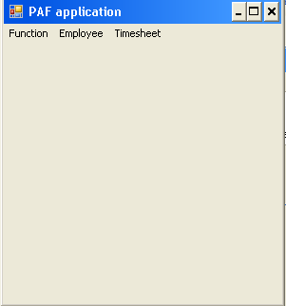
Main Menu

Sample UI 1: PAF Application

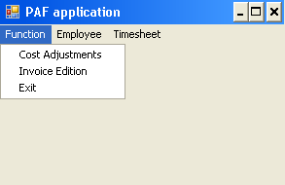

Sample UI 2: PAF Application->Function

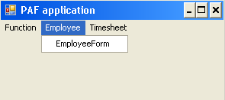

Sample UI 3.a: PAF Application->Employee

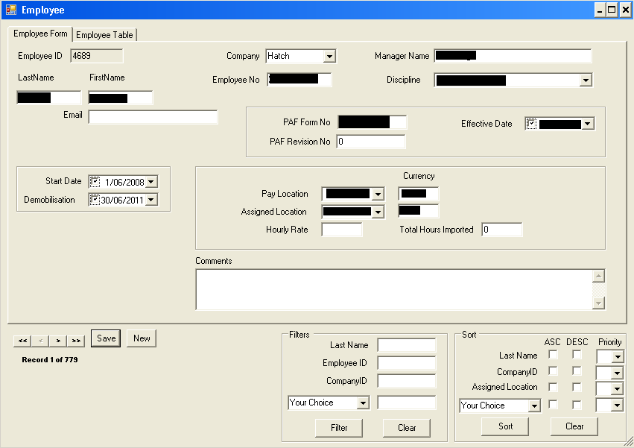

Sample UI 3.b: PAF Application->Employee->Employee Form

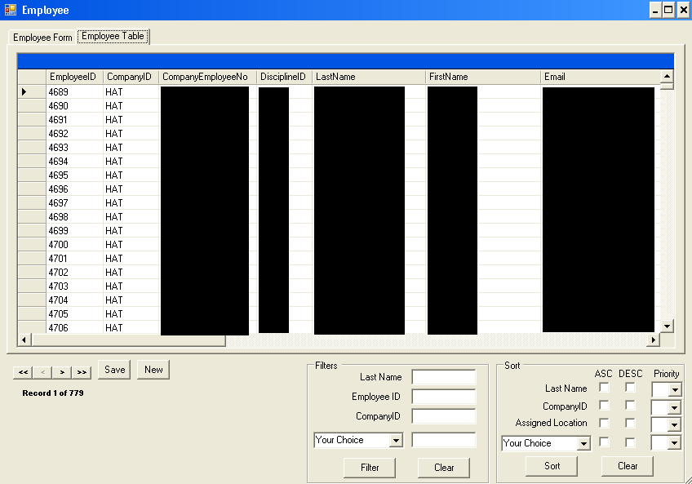

Sample UI 3.c: PAF Application->Employee->Employee Table

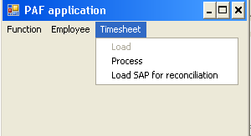

Sample UI 4.a: PAF Application->Timesheet

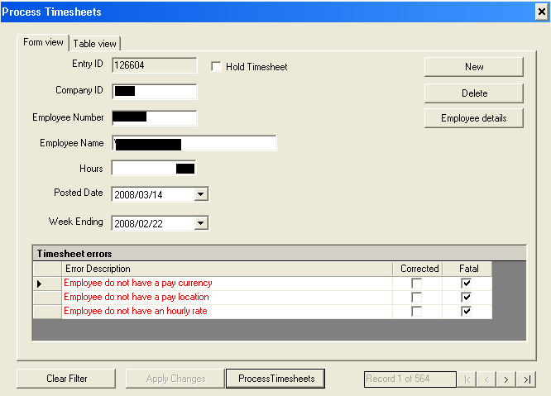

Sample UI 4.b: PAF Application->Timesheet->Process->Form View

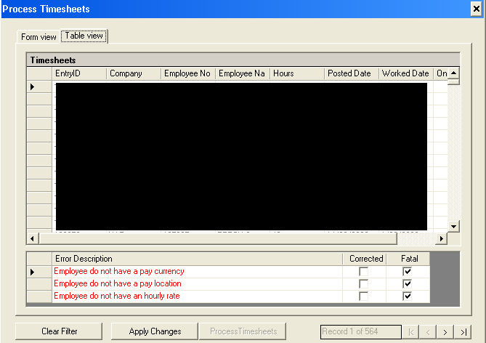
Sample UI 4.c: PAF Application->Timesheet->Process->Table View

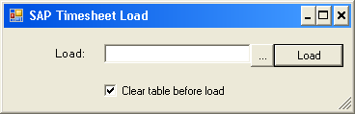
Sample UI 5: PAF Application->Timesheet->Load SAP for Reconciliation.

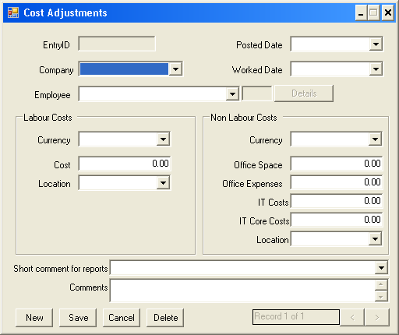

Sample UI 6: PAF Application->Function->Cost Adjustments

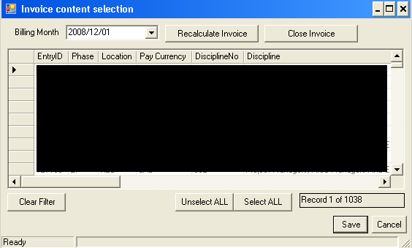

Sample UI 6: PAF Application->Function->Invoice Edition.

Appendix D
Invoice Report AND Extraction

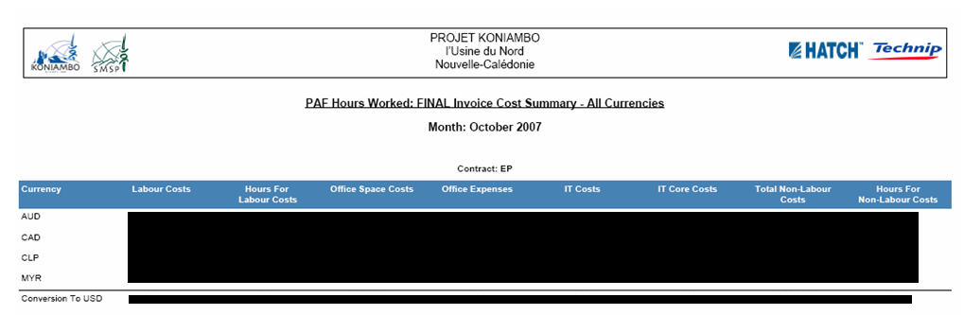
Sample Report 1: IF1: Invoice Cost Summary.
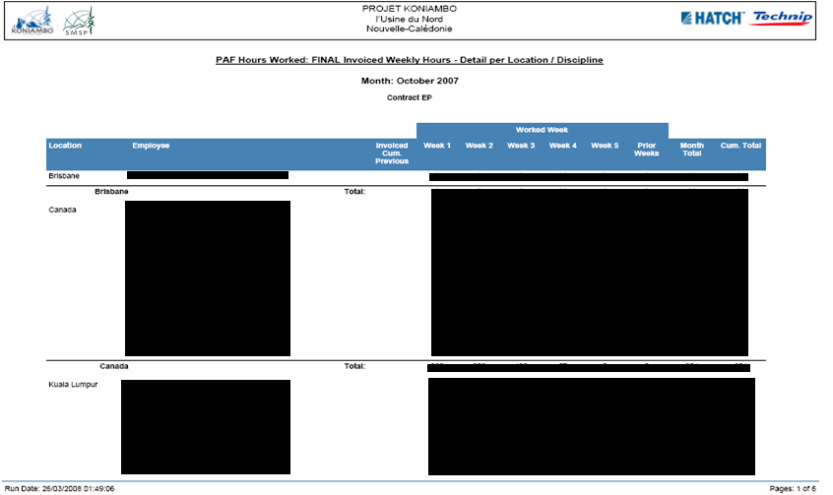
Sample Report 2.a: IF2: by Location

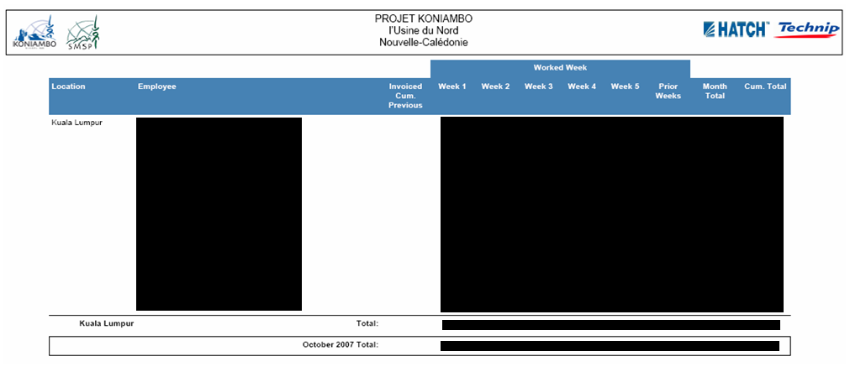

Sample Report 2.b: IF2: by Location

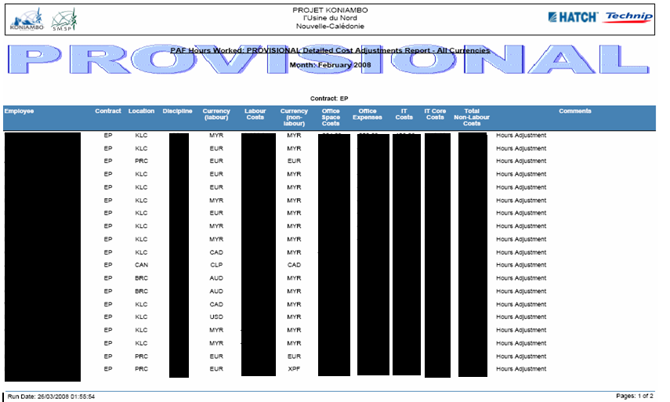
Sample Report 3: IF3: Detailed Adjustments Summary.

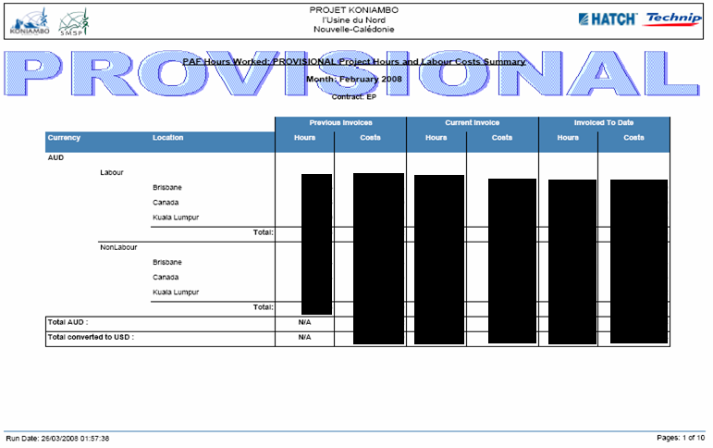
Sample Report 4: IF4: Hours & Labour Costs Summary

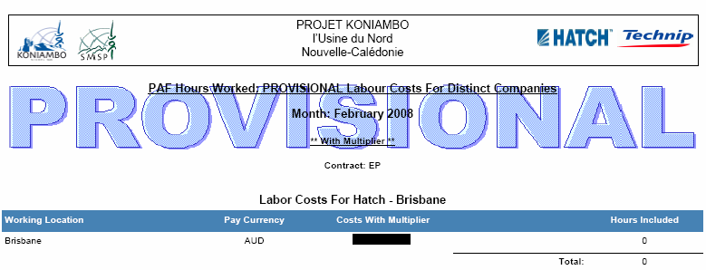
Sample Report 5: IG1: Labour Costs With Multiplier

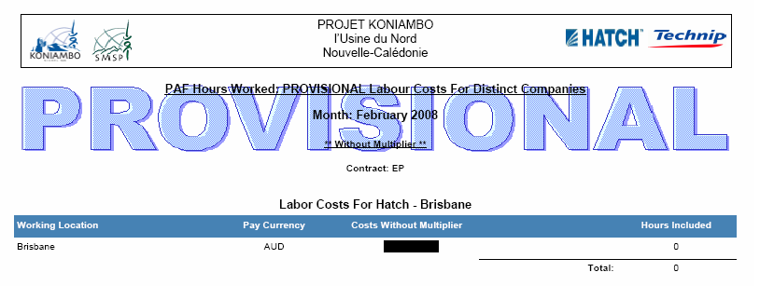

Sample Report 6: IG2: Labour Costs Without Multiplier

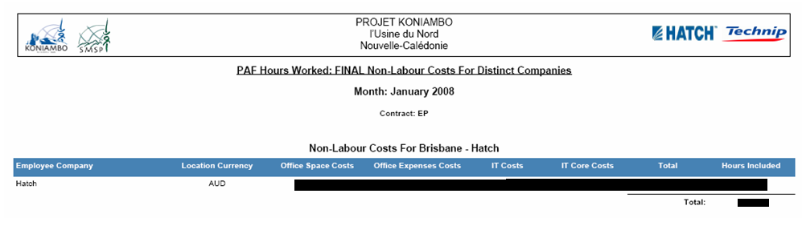

Sample Report 7: IG3: Non-Labour Costs

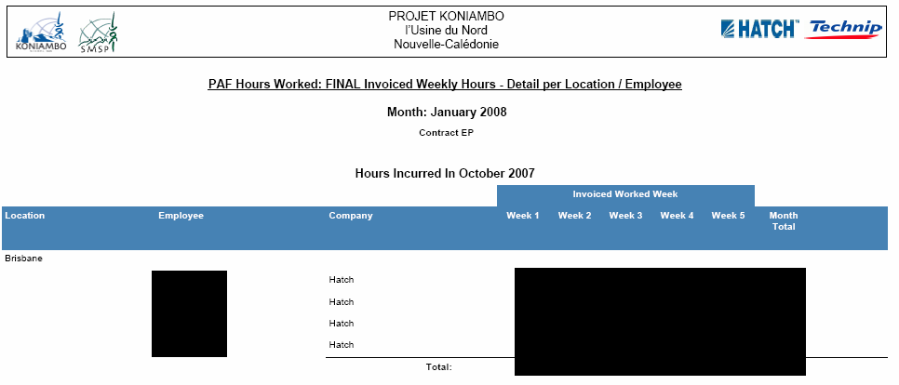
Sample Report 8.a: IG4: Location/ Employee

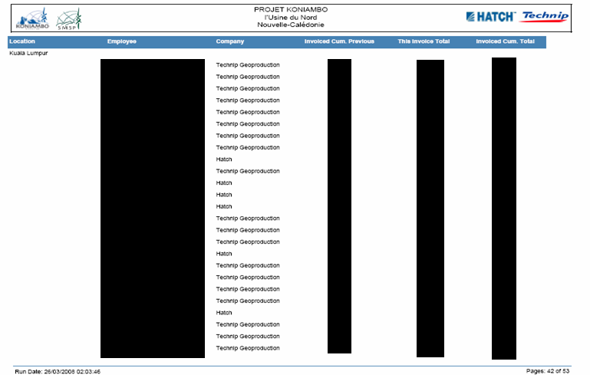

Sample Report 8.b: IG4: Location/ Employee

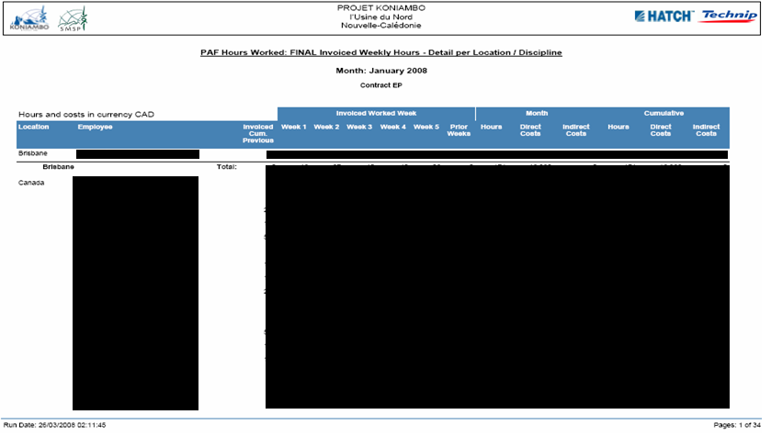

Sample Report 9: IF2 LC: by Location

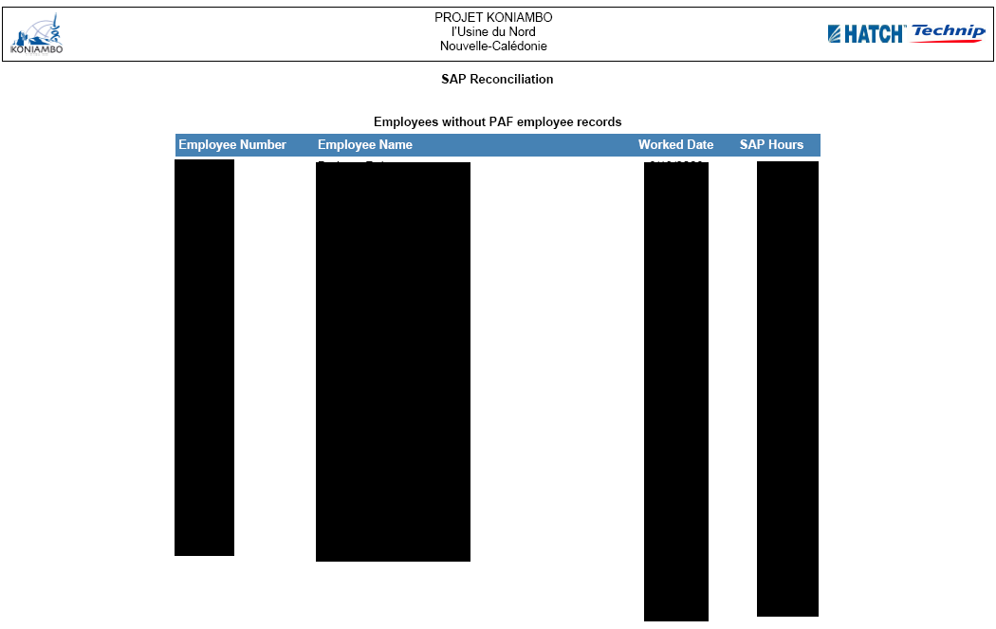

Sample Report 10: SAP Reconciliation NO PAF

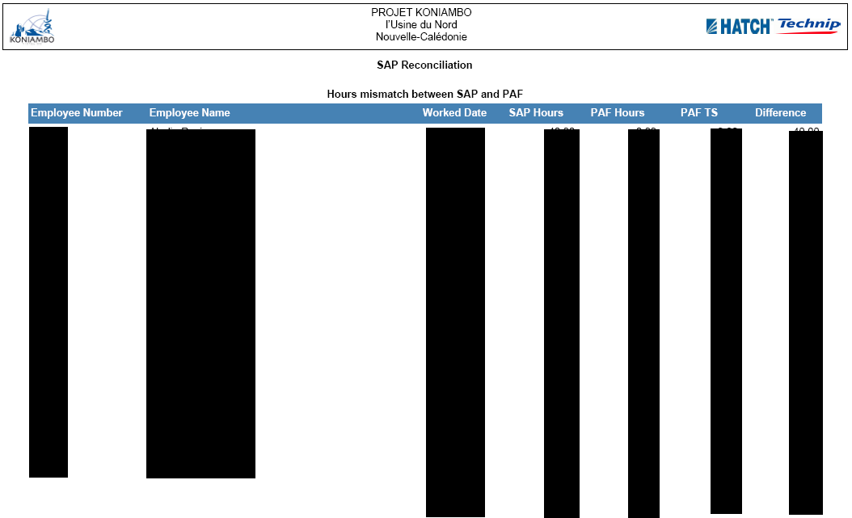

Sample Report 11: SAP Reconciliation Mismatch.
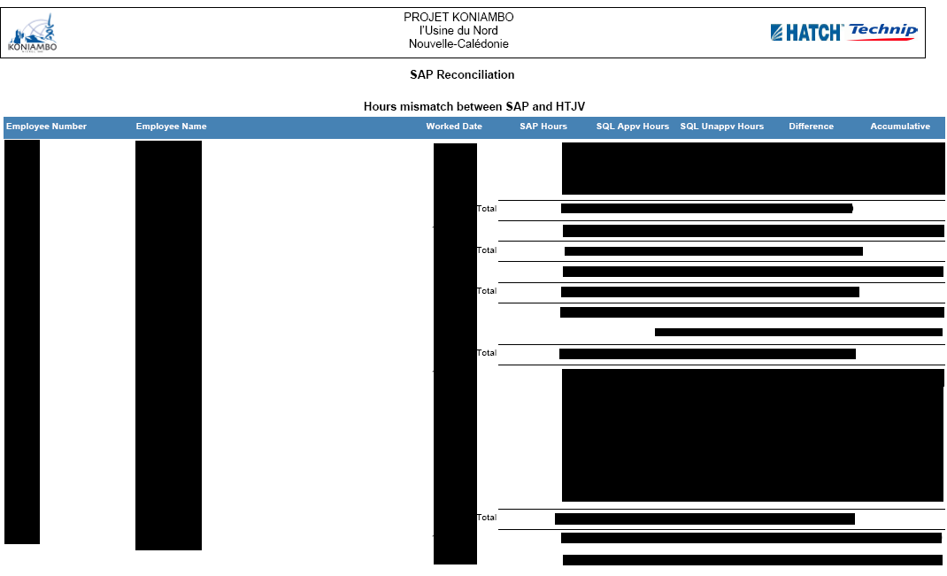

Sample Report 12: SAP HTJV Reconciliation

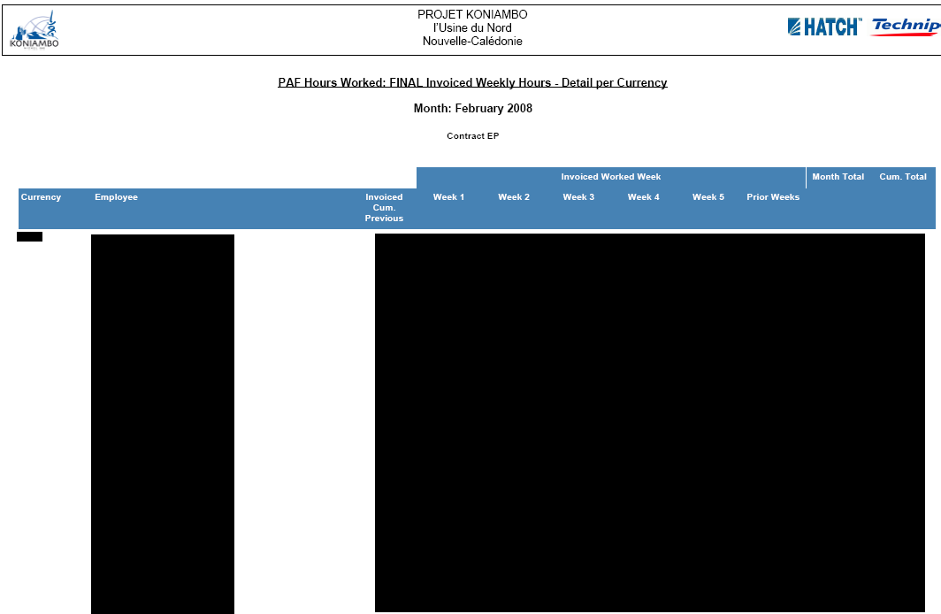

Sample Report 13: IF 2 Currency Employee
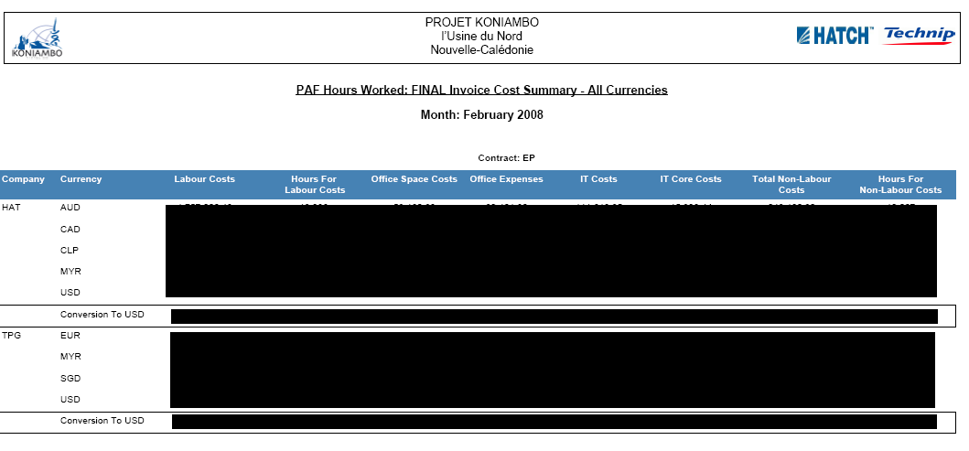

Sample Report 14: Invoice Cost Summary/Company

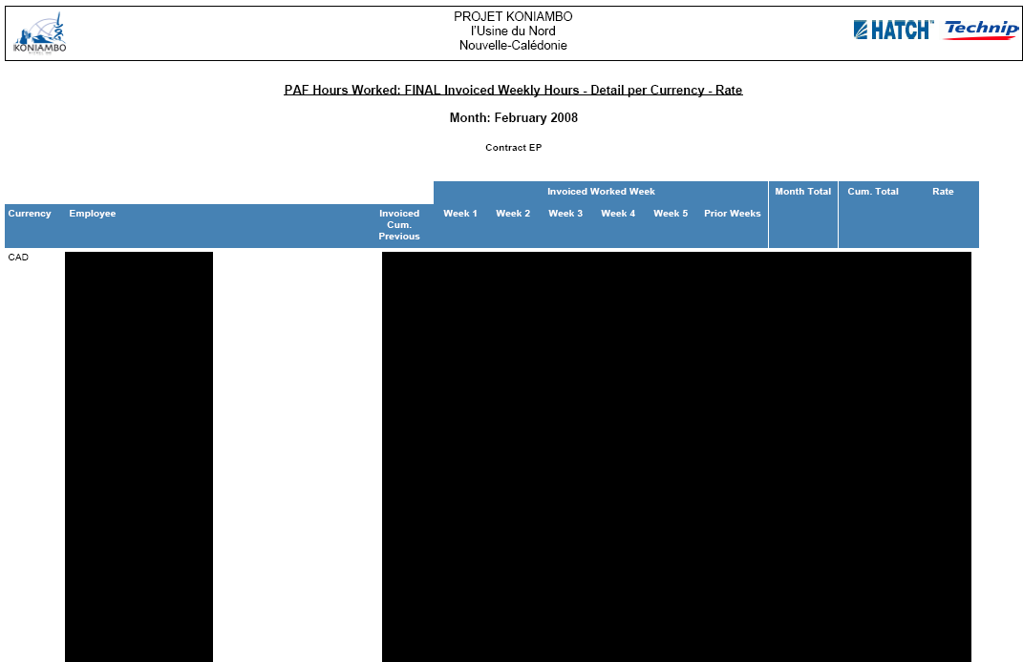
Sample Report 15: IF 2 Employee Rate

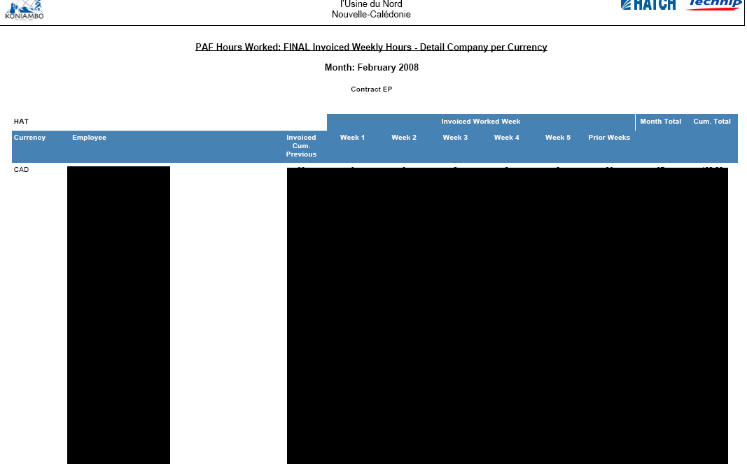
Sample Report 16: IF 2 Company Currency Employee

Sample Extraction 1: Employee Extraction

Sample Extraction 2: Full Employee Extraction

Sample Extraction 3: Employee History Extraction

Sample Extraction 4: Hour Extraction

Sample Extraction 5: Timesheets Extraction

Sample Extraction 6: Timesheets Errors Extraction

Sample Extraction 7: Timesheets Errors Extraction

Sample Extraction 8: SAP-HTJV-PAF Extraction

Sample Extraction 9: Monthly Manhour Extraction

Sample Extraction 10: Monthly Invoiced Extraction

Sample Extraction 11: Weekly Extraction.

